**PRASATH D - 212221020033**

EXP 6: Development of Python Code Compatible with Multiple AI Tools

Experiment:

Write and implement Python code that integrates with multiple AI tools to automate the task of interacting with APIs, comparing outputs, and generating actionable insights.

# Aim:

To compare the responses of two open-source language models, **GPT-Neo** and **GPT-2**, to a given question, and analyze how different models generate text and handle natural language queries.

# Procedure:

1. **Install Required Libraries**:

Use the command below to install the necessary Python libraries:

bash

Copy code

pip install transformers torch

# Load Models:

* + Load two pre-trained language models from Hugging Face:
    - **GPT-Neo** (EleutherAI/gpt-neo-1.3B).
    - **GPT-2** (gpt2).

# Define Functions:

* + Define two functions to generate text from both models.
    - **GPT-Neo Function**: Generates text from the GPT-Neo model.
    - **GPT-2 Function**: Generates text from the GPT-2 model.

# Generate Answers:

* + Input the question “What are the benefits of renewable energy?” to both models and generate their responses.

# Compare Answers:

* + Compare the generated answers from both models to see if they match or differ.
  + Print the responses and a summary indicating whether the answers are the same or different.

# Execute the Code:

* + Run the code to generate and compare answers.

# Deliverables:

1. **Python Script**: A script to compare answers from two models.
2. **Comparison Output**: The answers generated by both models and a summary of whether the answers are similar or different.

# Sample Code:

from transformers import pipeline

# Load GPT-Neo and GPT-2 models

generator_neo = pipeline('text-generation', model='EleutherAI/gpt-neo-1.3B') generator_gpt2 = pipeline('text-generation', model='gpt2')

# Function to get answer from GPT-Neo def get_gpt_neo_answer(question):

generated_text = generator_neo(question, max_length=100, num_return_sequences=1) return generated_text[0]['generated_text']

# Function to get answer from GPT-2 def get_gpt2_answer(question):

generated_text = generator_gpt2(question, max_length=100, num_return_sequences=1) return generated_text[0]['generated_text']

# Function to compare answers from both models def compare_answers(question):

answer_gpt_neo = get_gpt_neo_answer(question) answer_gpt2 = get_gpt2_answer(question)

print("GPT-Neo Answer:", answer_gpt_neo) print("GPT-2 Answer:", answer_gpt2)

if answer_gpt_neo == answer_gpt2:

summary = "Both models provided the same answer." else:

summary = "The answers are different." print("Summary:", summary)

return {

"question": question, "gpt_neo_answer": answer_gpt_neo, "gpt2_answer": answer_gpt2, "summary": summary

}

# Run the comparison with a sample question question = "Give the advantages of MRI scan?"

result = compare_answers(question) print("Comparison Result:", result)

# Result:

**GPT-Neo Answer**: **Give the advantages of MRI scan?**

It’s one of the hottest topics in the world of medical imaging and has become the number one topic in the field to improve the process of diagnosis. MRIs are the best in terms of resolution, speed and accuracy. Although MRI is a safe procedure, there is little research published on the results of this image-guided diagnosis tool.

MRIs can also be used for various clinical purposes, such as for the imaging of tumors, cysts.

**GPT-2 Answer: Give the advantages of MRI scan?**

Visit our 'Median Age of Magnetic Resonance' webpage.In 2008, the U.S. has had only 50 MRI scans. The national age of magnetic resonance imaging is 16, or 21.6 years old.

The US National Institutes of Health has announced, based on the research, that it can be expected to have 5 MRI scans for every 100 million people.

For the first time ever, the medical field has agreed to.

**Summary: The answers are different.**

**Comparison Result:Give the advantages of MRI scan? gpt_neo_answer: Give the advantages of MRI scan?**

It’s one of the hottest topics in the world of medical imaging and has become the number one topic in the field to improve the process of diagnosis. MRIs are the best in terms of resolution, speed and accuracy. Although MRI is a safe procedure, there is little research published on the results of this image-guided diagnosis tool.

MRIs can also be used for various clinical purposes, such as for the imaging of tumors, cysts.

**gpt2_answer: Give the advantages of MRI scan?**

Visit our 'Median Age of Magnetic Resonance' webpage.In 2008, the U.S. has had only 50 MRI scans. The national age of magnetic resonance imaging is 16, or 21.6 years old.The US National Institutes of Health has announced, based on the research, that it can be expected to have 5 MRI scans for every 100 million people.For the first time ever, the medical field has agreed to.

**summary: The answers are different.**

# Sample Output:

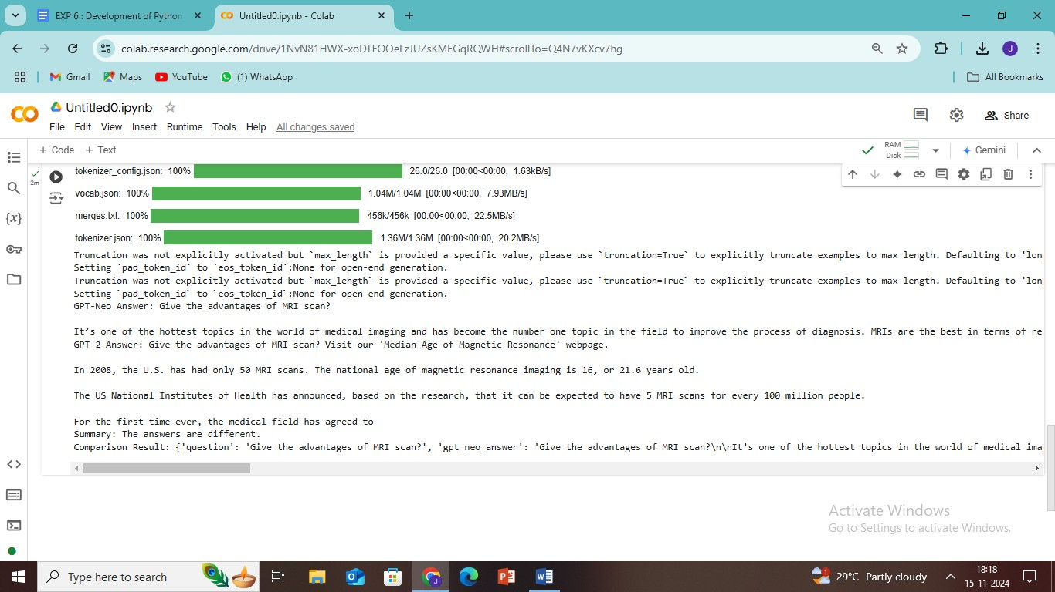

**Conclusion:**

In this experiment, we compared the responses of two different language models, **GPT-Neo** and **GPT-2**, to the same input question. The results showed that the models provided different answers, which indicates that each model has its unique way of generating text based on its training data and architecture.